Name | Swayam Ramdin
Roll no | 24204B0061
Batch | 03
Subject name | Python Programming & Data Structure
Teacher Name | Ms. Rasika Patil

Experiments | 9
Title | Develop python program to define class Student with data members (Roll no, Name, Course, Percentage) as input and then print the details.

Programming Questions with Answer
1 | Program to create a Student class and display details
SCRIPT | class Student:  def __init__(self, name, age, course):  self.name = name  self.age = age  self.course = course  def display(self):  print("Name:", self.name)  print("Age:", self.age)  print("Course:", self.course)  s1 = Student("Swayam Ramdin", 19, "Engineering")  s1.display()
OP | 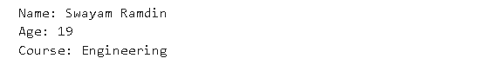
2 | Program using constructor to initialize student details
SCRIPT | class Student:  def __init__(self, name, age, marks):  self.name = name  self.age = age  self.marks = marks  def display(self):  print("Name:", self.name)  print("Age:", self.age)  print("Marks:", self.marks)  s1 = Student("Swayam Ramdin", 19, 79)  s1.display()
OP | 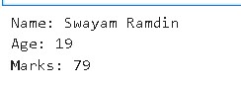
3 | Program to take multiple student objects
SCRIPT | class Student:  def __init__(self, name, age, course):  self.name = name  self.age = age  self.course = course  def display(self):  print("Name:", self.name)  print("Age:", self.age)  print("Course:", self.course)  print()  students = []  n = int(input("Enter number of students: "))  for i in range(n):  name = input("Enter name: ")  age = int(input("Enter age: "))  course = input("Enter course: ")  students.append(Student(name, age, course))  for s in students:  s.display()
OP | 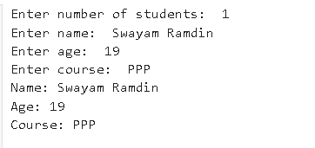
Debugging Questions with Corrected Answers
1 | Debug the following code  Wrong code:  class Student  def __init__(self):  self.name = "Amit"
OP | Error:  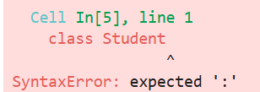  Correct code:  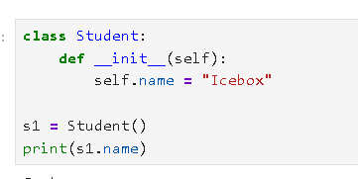
2 | Debug the following code  Wrong code:  class Student:  def show():  print("Hello")  obj = Student()  obj.show()
OP | Error: 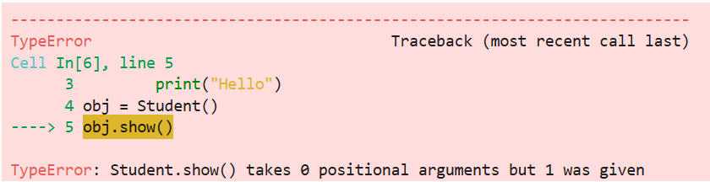  Correct code:  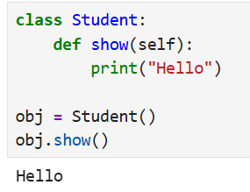
Conclusion

Performance Indicators |  | Teachers Dated and Signature
Process Related  (15 M) | Product Related  (10 M) | Total (25 M)

